OCAP: Out of Control Action Plan

The following has been pulled from: “Statistical Applications in Process Control” edited by J. Bert Keats, Couglas C. Montgomery, pgs 96-99

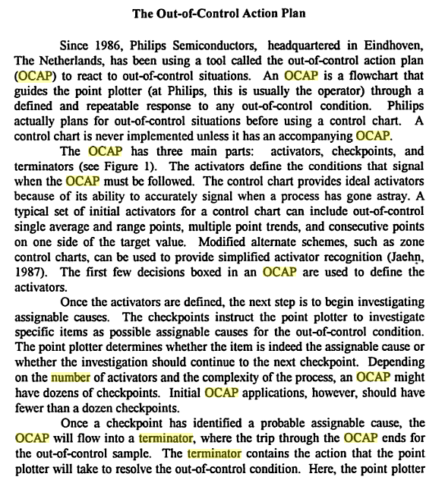
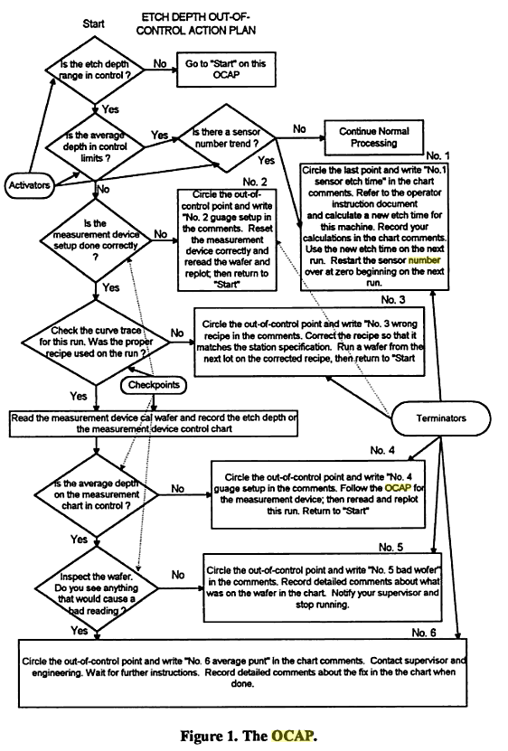

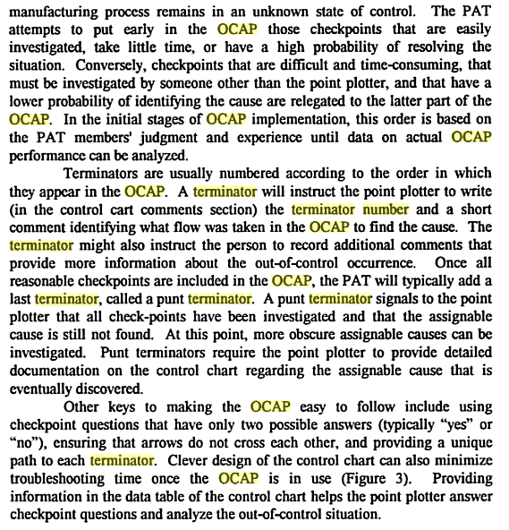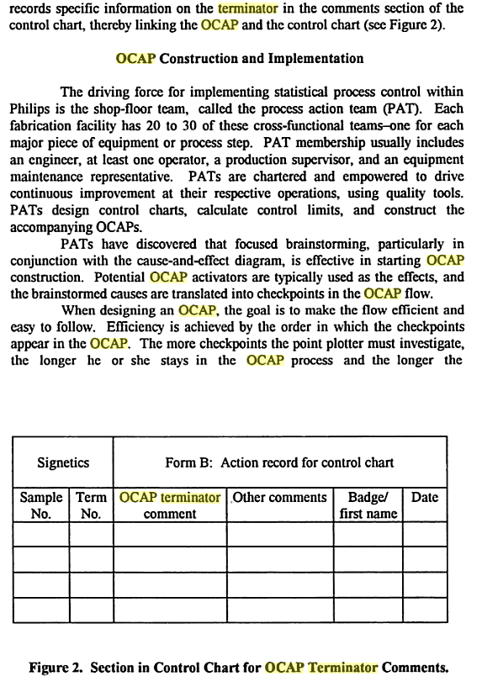

The following was extracted from the following website: http://www.whatissixsigma.net/six-sigma-dmaic-control-phase/
If process control involves carrying out of identifying and employing practical actions, Out of Control Action Plan refers to setting the plans in order to take action correctly to “out of control” signs. This can anticipate the course performance. Course changes are handled effectively and steadiness is ensured in the event of new conditions. This also allows early discovery of impending causes or problems before it becomes a problem.
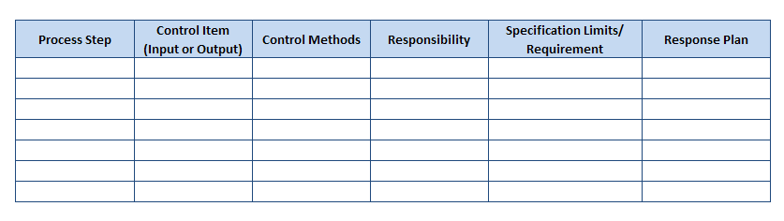
OCAP Table – Out of Control Action Plan Table
The table above is a draft of OCAP. The continuous procedure should be noted under the process step header. Control Item indicates the key course inputs that need to be managed to meet the production requirement. It should also include the key course outputs that need to be observed for signs requiring awareness. Control method should include control chart, metrics, after action reviews, approvals, and trainings. Responsibility notes the group or an individual who owns the job. Specification Limits/Requirements will show the customer measurement limits or requirements of the internal performance. Response plan should note the counteractive actions to solve/contain the problem and reduce losses. The table below shows an example of an OCAP:
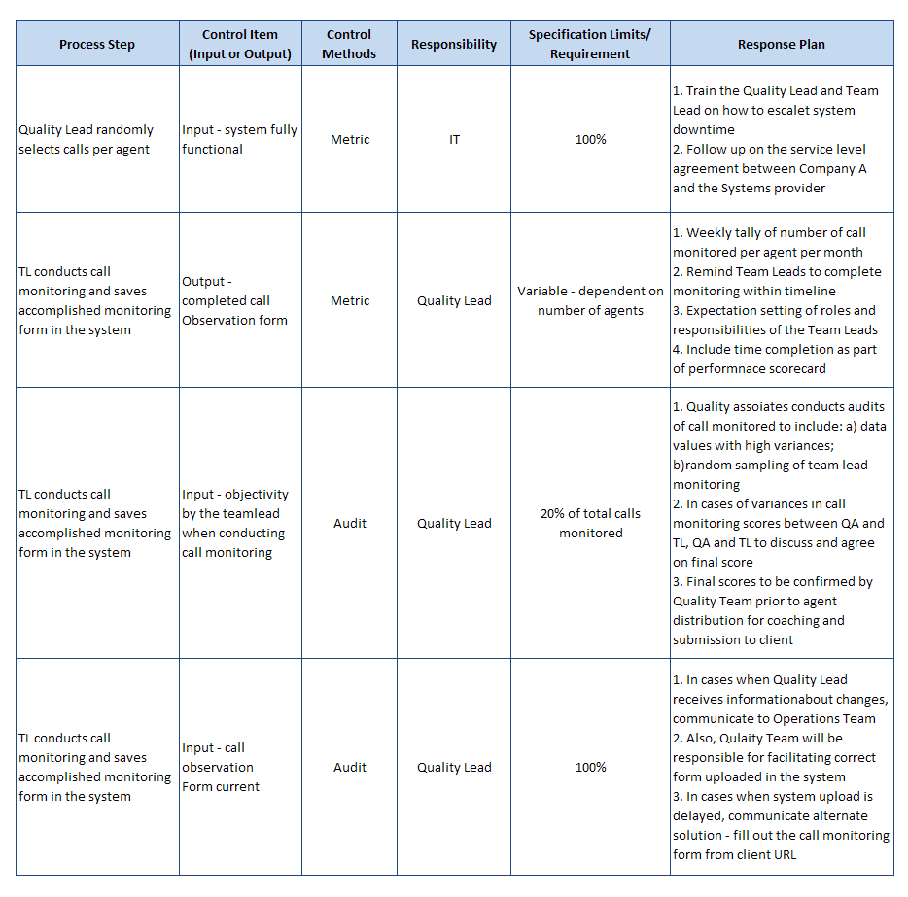
OCAP Table Example
Control plans may include other data than the one presented. The important thing is that they must be available, controlled and trained to.

